Institutional Distinctiveness (2020-2021)
The institution still maintains it’s distinctiveness though it is affected by Covid -19 pandemic. All the positive practices initiated in the previous session were carried and followed in the next session.
New intitiatives taken by the institution are as follows:
- Covid Warriors : Final year 13th batch students (29) volunteered to relieve the nursing staff of State Referral Hospital Falkawn/Zoram Medical College as a Covid Voluntary Frontliners after undergoing training on Covid 19 from 25th May 2021.
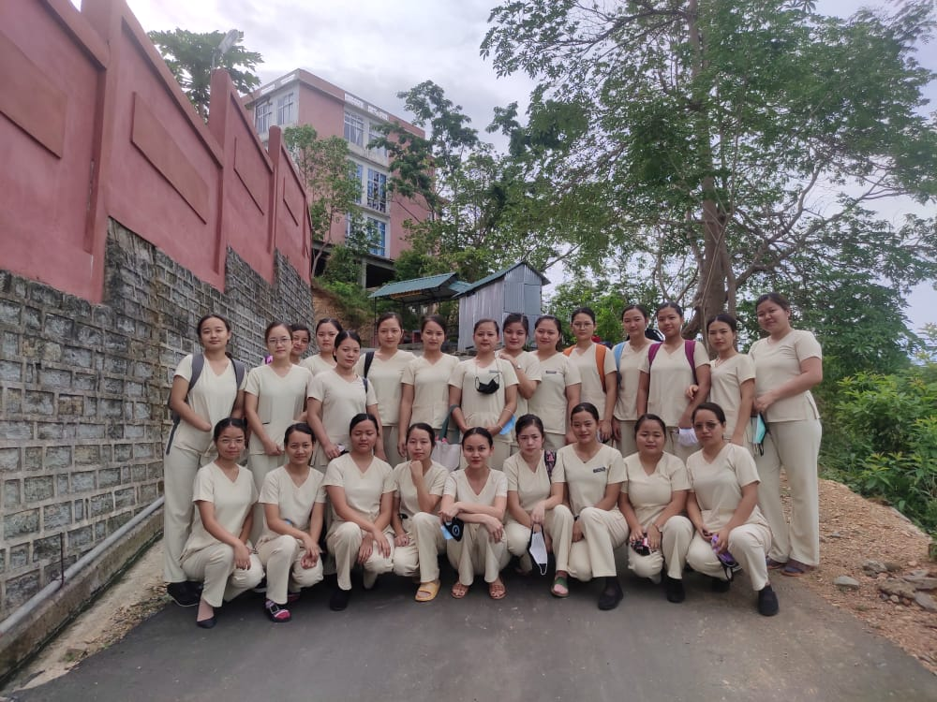

- Webinar : The institution organizes 4 National Webinars. Resource persons invited from reputed organizations from International Council of Nurses, IGNOU. Also eminent institutions such as LGBRIMH Tezpur, Mizoram University, Tarsadia University and well established nursing colleges from Kolkata, Mumbai etc.
The following topic were covered.
- Decoding National Education Policy 2020
- Promoting Mental Health in Times of Pandemic
- Promoting excellence in Nursing Profession Through Nursing Research
- Infection Control –Saving Lives Through Prevention
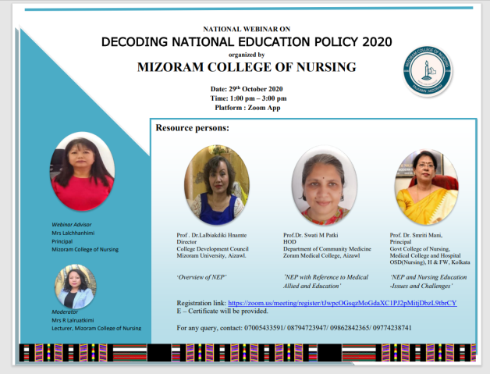
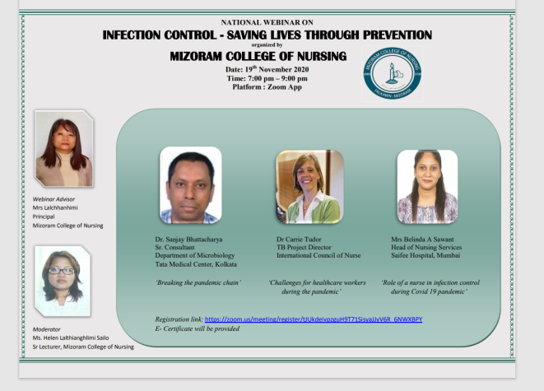

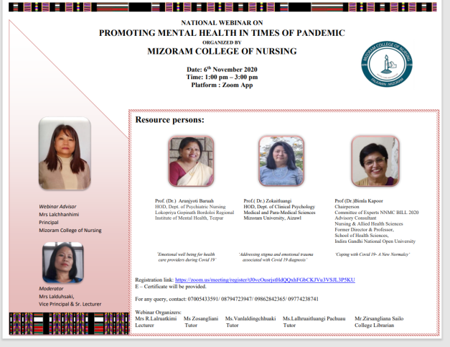
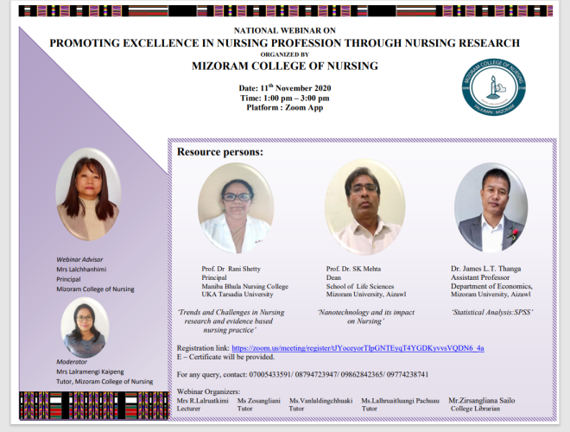

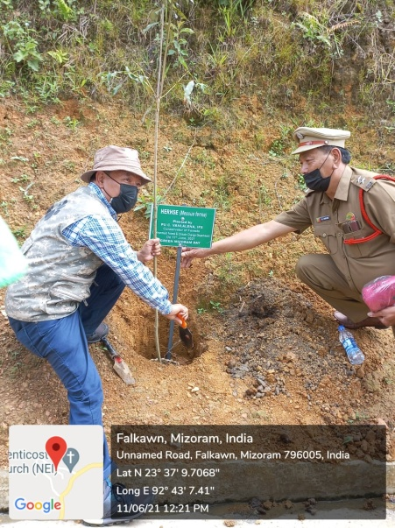
- Green Initiatives : In collaboration with EF & CC (Environment)Dept, Govt. of Mizoram, ‘Green Mizoram Day’ is observed by planting more than 50 saplings within the campus. A consolation price (Rs.1000) is secured in “Tree plantation Selfie challenge”organized by ‘Mizo Photographers’ Society’
