Institutional Situatedness
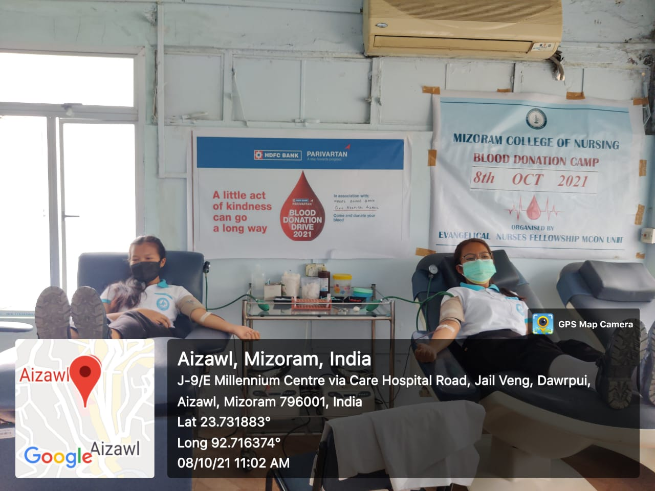
Pic 1 : Blood Donation at Civil Hospital Aizawl on 8th Oct 2021
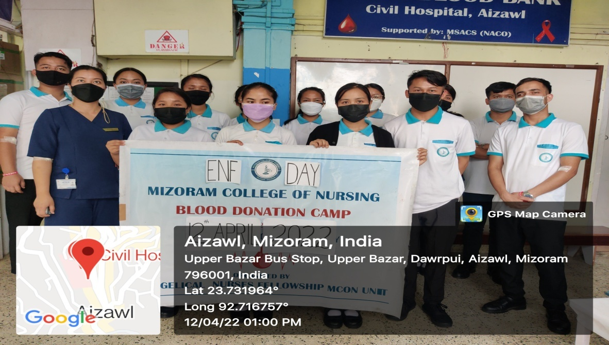
Pic 2 : Blood Donation at Civil Hospital Aizawl on 12th April 2022

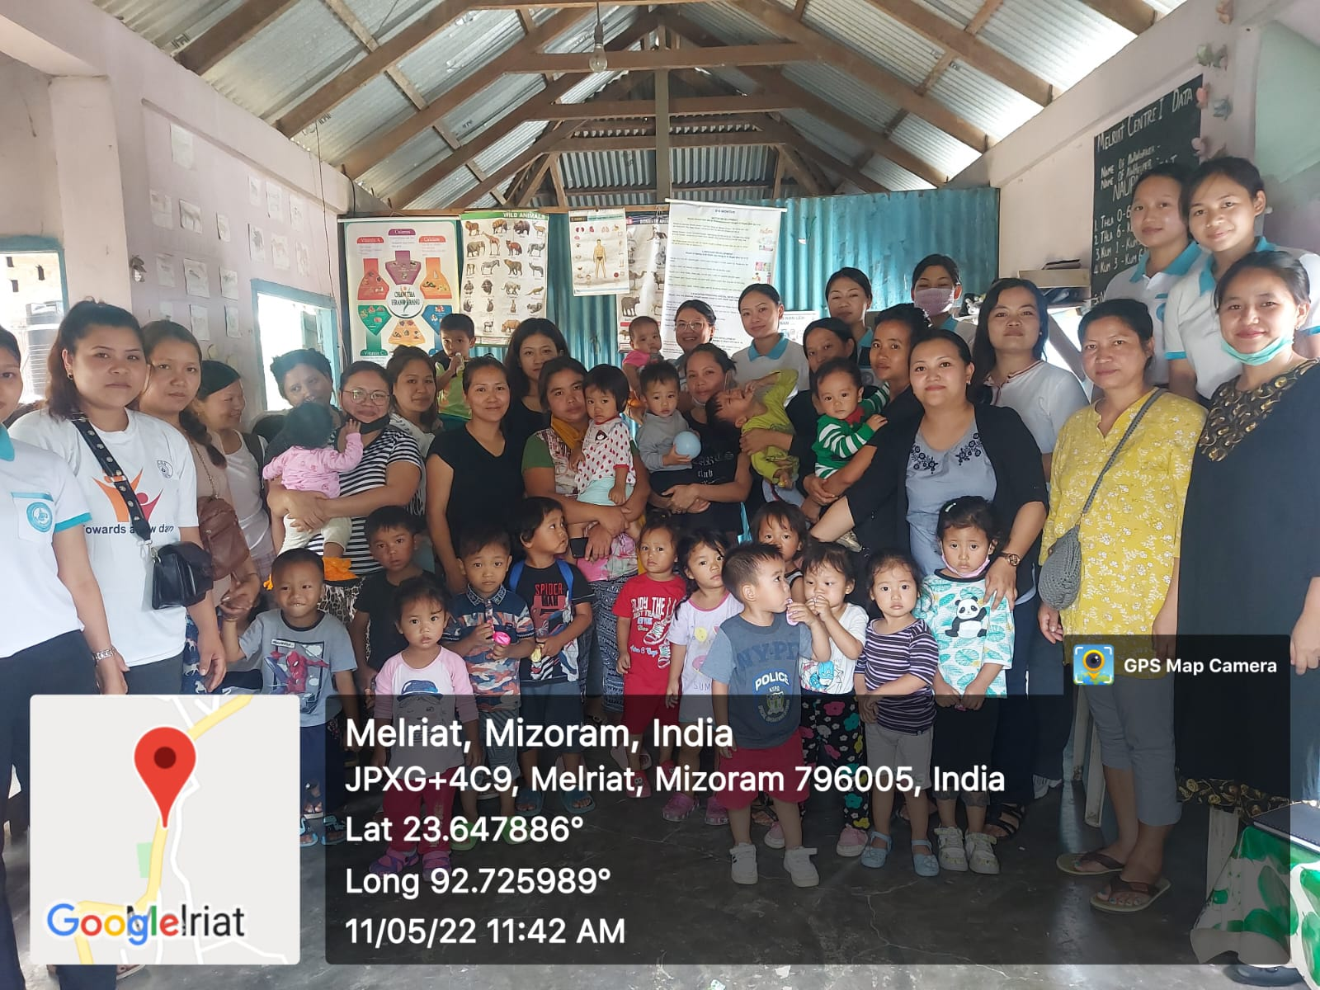
Pic 3: Anganwadi Visit at Rural area on 5th May 2022
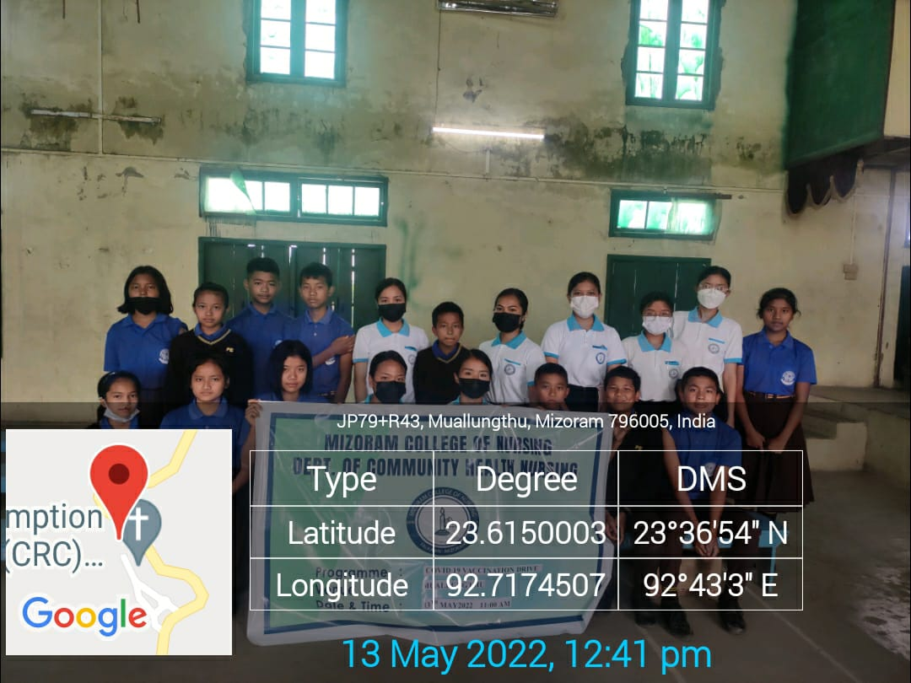
Pic 4 : School Visit on 13th May 2022

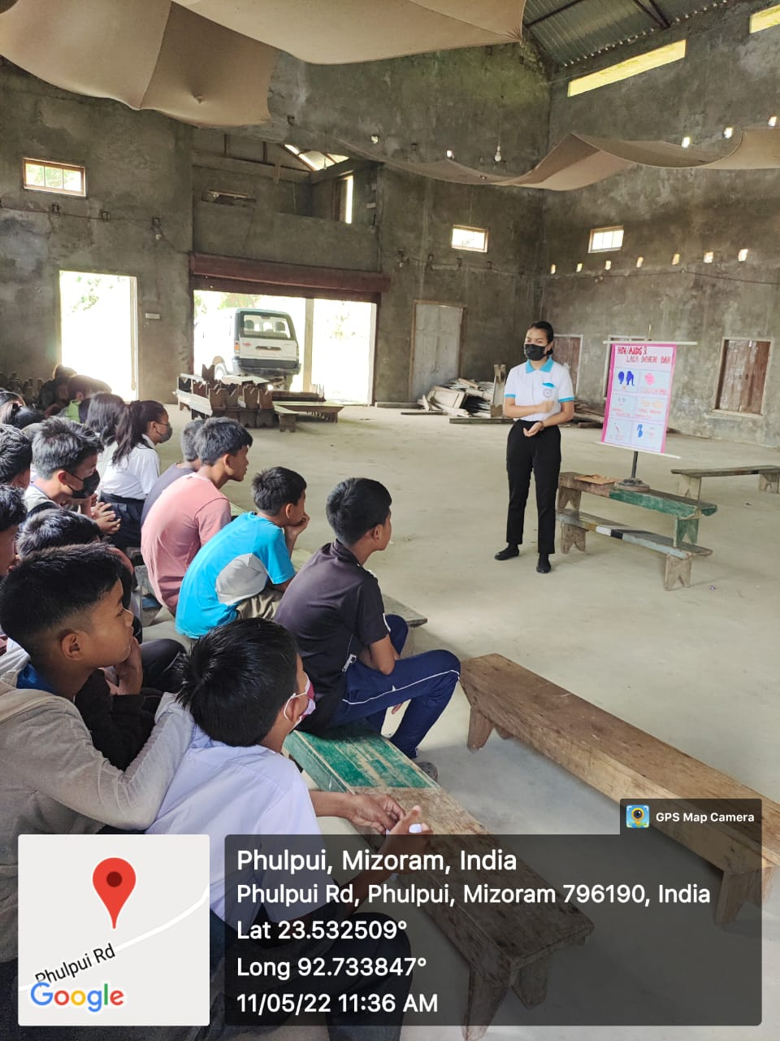
Pic : 5 Community Health Teaching at rural area on 11th May 2022
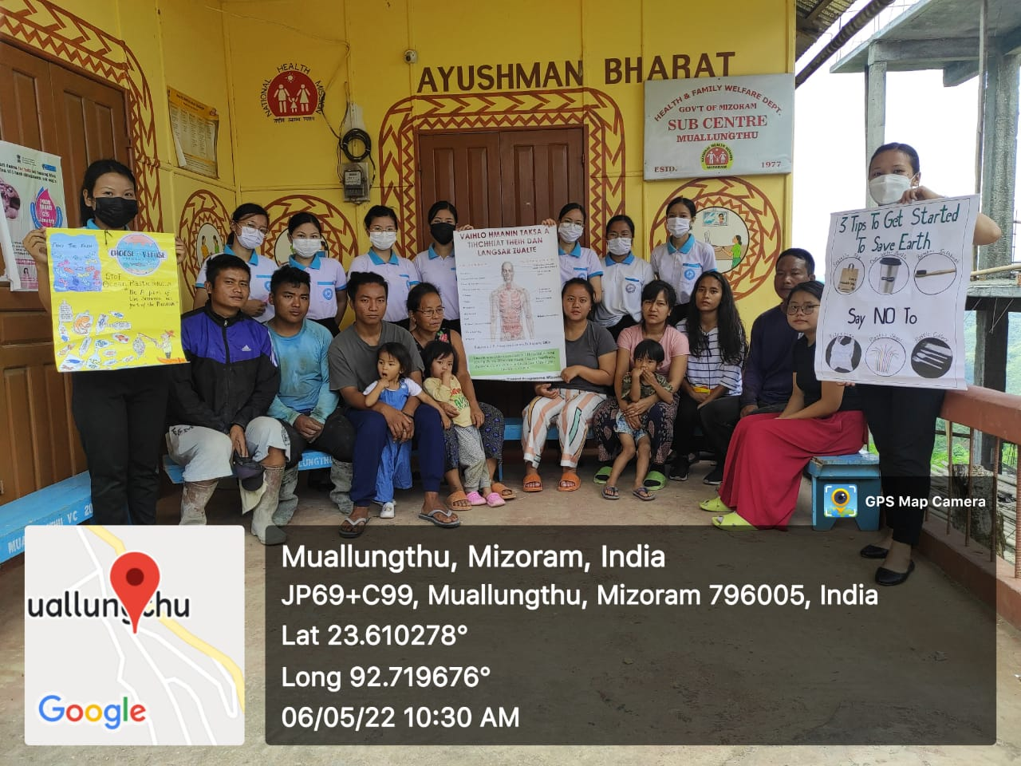
Pic 6 : No Plastic Use Campaign & No Tobacco Use Campaign at Health Sub Centre

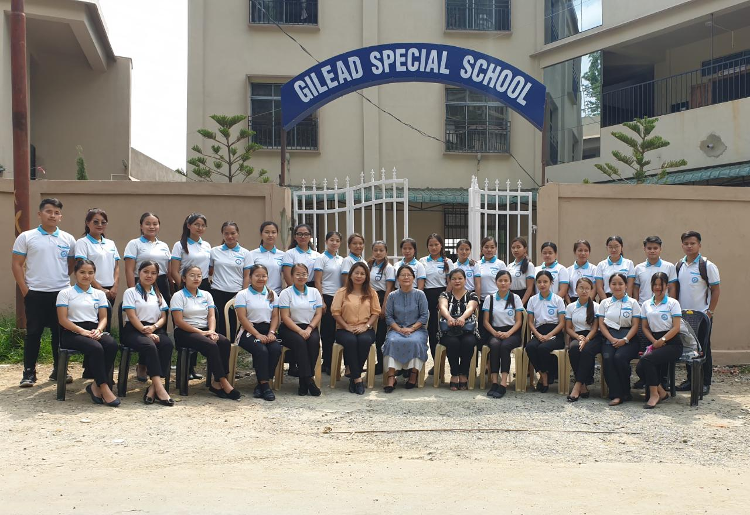
Pic 7 : Visit Gilead Special School (Handicapped & Disabled) on 9th June 2022
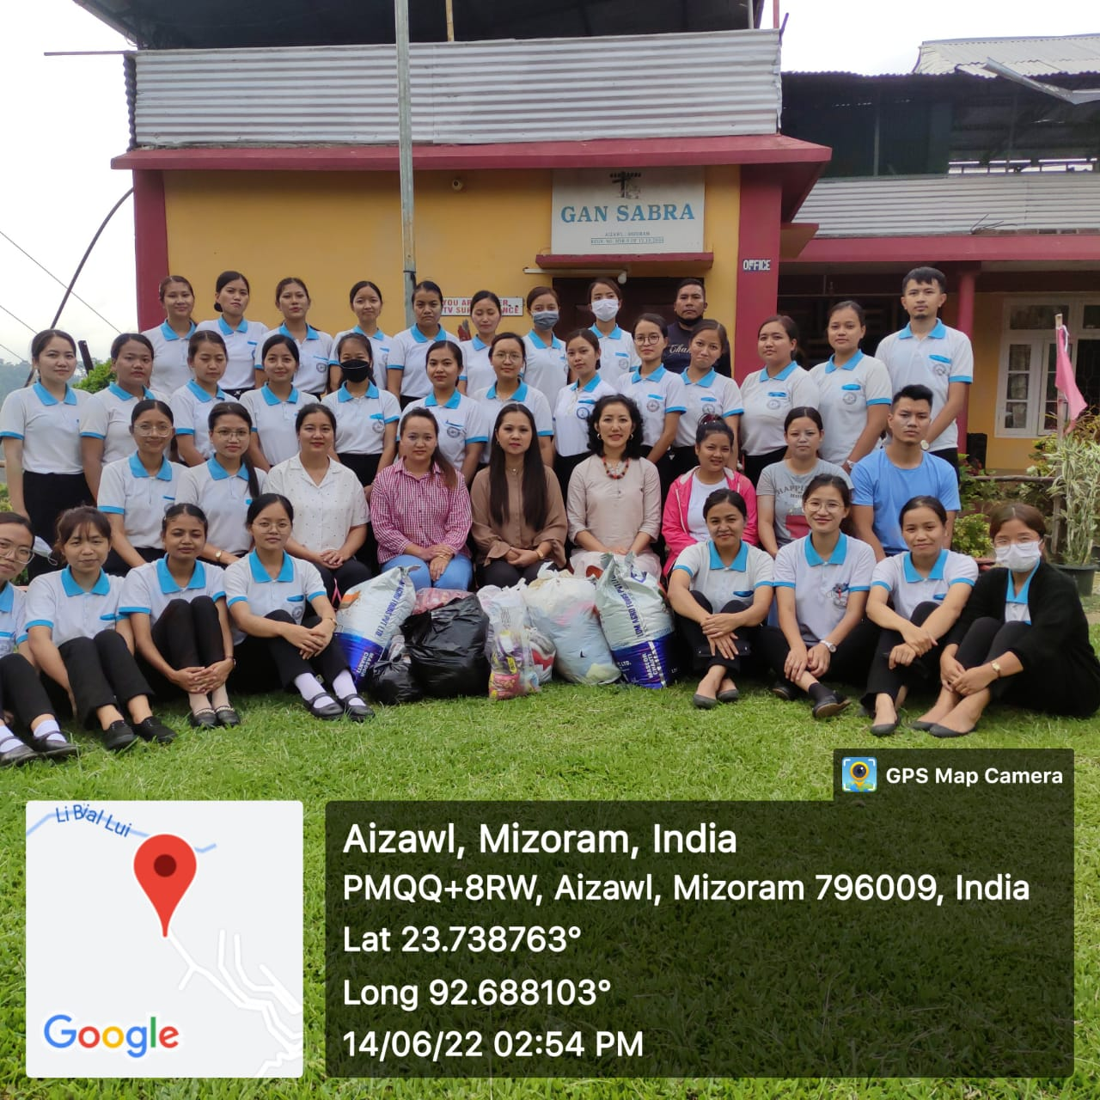
Pic 8 : Visit Gan Sabra (HIV Positive children) on 16th June 2022

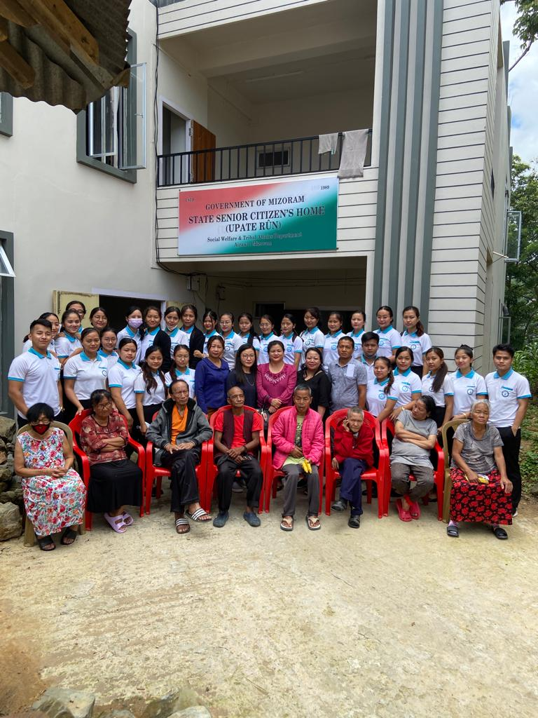
Pic 9 : Visit State Senior Citizen’s Home on 21st June 2022

