2.4.4.e-contents/e-courses developed
List of e-contents developed during the academic year
Sl No | Topic | File Type | Link to the document
1 | World AIDS Day 2021 Observation | mp4 | CLICK HERE
2 | Welcome address for ENFI National Biennial Conference 2021 | mp4 | Welcome speech
3 | Material for ENFI National Biennial Conference 2021 | mp4 | special Number
4 | State Level RRC Quiz Virtual Banner | jpeg | Virtual banner
5 | Result announcement for WORLD AIDS DAY Poster & Essay writing competition | mp4 | CLICK HERE

Besides this, Teaching materials in the form of PDF, PPT and DOC file used for taking classes are shared with the student from 1st year to 4th Year
Applications/ tools used for accessing e-content/ e – courses

Safe Delivery App - Maternity Foundation

OpenWHO: MOOCs - start to enjoy learning now

Link for accessing and downloading free medical textbooks in pdf form shared with the students are-
1. https://nlist.inflibnet.ac.in
2. https://www.pdfdrive.com/
3. https://www.booksasia.co.uk/
Students are also given a joining link for Whatsapp group where free teaching materials are provided-
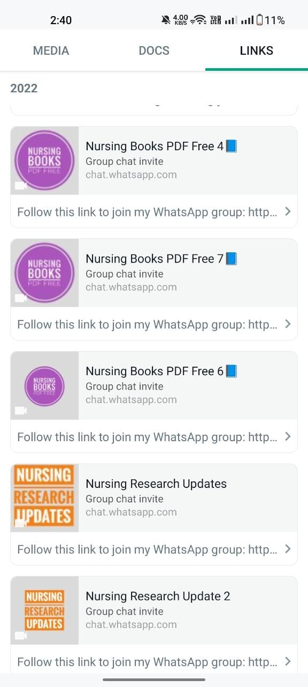
List of State Level Online Bible Study conducted by ENF MCON Unit in collaboration with ENF Mizoram State Branch -
- 
 