2.4.4.e-contents/e-courses developed
List of e-contents developed during the academic year
Sl No | Topic | File Type
1 | Soft Skills ( Elective Module) made by teachers of 1st Semester and 3rd Semester | Pdf and Hard copy
2 | Teaching materials is made by all teachers for theory classes & demonstration | Pptx, Pdf, Docx, mp4
3 | Auscultation of Lung Sounds- Normal and Abnormal | mp4
4 | Subcutaneous Injection | mp4
5 | Intradermal Injection | mp4

Teaching materials in the form of PDF, PPT, VIDEOS and DOC file used for taking classes are shared with the student from 1st year to 4th Year.
Applications/ tools used for accessing e-content/ e – courses
https://www.jhu.edu/academics/online/

Safe Delivery App - Maternity Foundation

OpenWHO: MOOCs - start to enjoy learning now

https://www.youtube.com/results?search_query=registered+nurse+rn
Link for accessing and downloading free medical textbooks in pdf form shared with the students re-
1. https://nlist.inflibnet.ac.in
2. https://www.pdfdrive.com/
3. https://www.booksasia.co.uk/
4. https://libgen.li/
5. Students are also given a joining link for Whatsapp group where free teaching materials are provided-
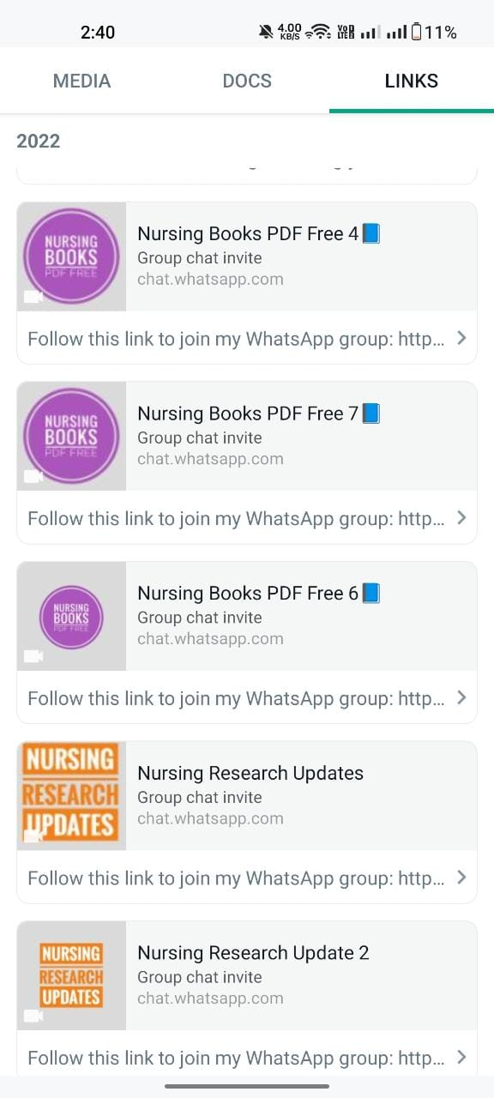
E-COURSES DEVELOPED BY MCON-ECHO

State Level e-course “MCON- Induction Training for Nursing Teachers-ECHO”
is developed by collaboration of MCON and ECHO India for all BSc Nursing Teaching faculty of Mizoram. It was conducted every 2 weeks on Thursday from 18 Aug 2022 to 24 Nov 2022
Description
The undergraduate nursing program is broad based education within an academic curricular framework specifically directed to the development of critical thinking skills, competencies appropriate to human and professional values. The main roles of graduates would be provider of care with beginning proficiency in delivering safe care, coordinator/manager of care by being active participant of inter-professional team and member of a profession demonstrating self-responsibility and accountability for practice as well as to support the profession. The faculty has the responsibility to be role models and create learning environment that facilitates cultivation of critical thinking, curiosity, creativity and inquiry driven self- directed learning and attitude of life-long learning in students. Learners and educators interact in a process whereby students gain competencies required to function within their scope of practice.

Schedule-
18 Aug 2022 | 01:00 pm - 02:30 pm IST

Pre-Launch & Spokes Orientation

01 Sep 2022 | 01:00 pm - 02:30 pm IST

SESSION-I Inauguration, Forensic Nursing-I

08 Sep 2022 | 01:00 pm - 02:30 pm IST

Session 2: FORENSIC NURSING-II

15 Sep 2022 | 01:00 pm - 02:30 pm IST

FUNDAMENTALS OF PRESCRIBING UNDER PHARMACOLOGY – I

29 Sep 2022 | 01:00 pm - 02:30 pm IST

Session 4: FUNDAMENTALS OF PRESCRIBING UNDER PHARMACOLOGY - II

06 Oct 2022 | 01:00 pm - 02:30 pm IST

Session 5: Palliative Care Nursing-I

13 Oct 2022 | 01:00 pm - 02:30 pm IST

Session 6: PALLIATIVE CARE NURSING II

20 Oct 2022 | 01:00 pm - 02:30 pm IST

Session 7: HEALTH ECONOMICS

03 Nov 2022 | 01:00 pm - 02:30 pm IST

Session 8: SCIENTIFIC WRITING SKILLS

10 Nov 2022 | 01:00 pm - 02:30 pm IST

Session 9: SCIENTIFIC WRITING SKILLS-II

24 Nov 2022 | 01:00 pm - 02:30 pm IST

Session 10: Sports Health

