2023-2024 STUDENT ACTIVITIES

6.06.2023 : Election of ENF OB 2023-2024
Election of ENF Office bearers was held for the Year 2023-2024 and the following are the elected members.
Chairman Ms Zuvelin VL Rosangi Reia
Vice Chairman Michael Lalsawmliana, IV Year
Secretary Ms Lalhriatpuii Varte
Asst. Secretary L.H Julie Lalremruati, IV Year
Treasurer Lalliantluangi Sailo, V Semester
Financial Secretary Amy Lalruatkimi, III Semester
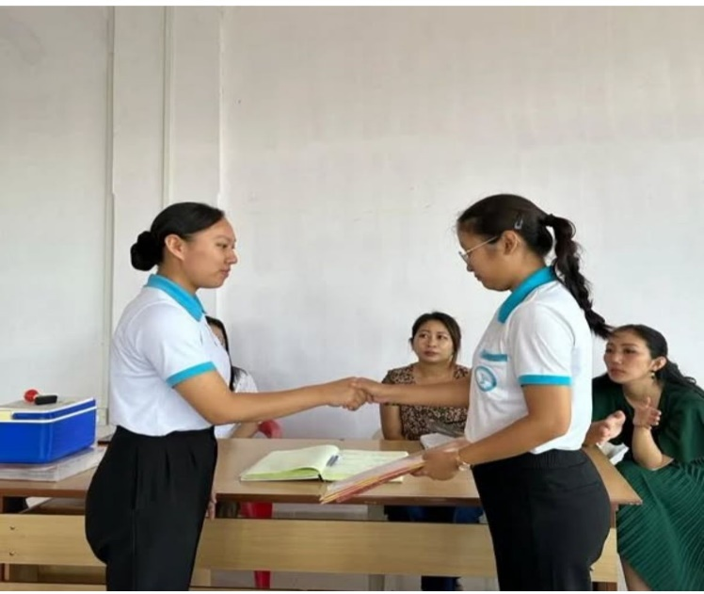

6.06.2023-2024 : ENF SERVICE-
ENF Service is carried out twice a month(Alternate Mizo and English service) on Monday at 12:00 PM in M-Hall ; every Friday at 7:00 PM in Hostel Devotion Hall and every Thursday during clinical postings at Civil Hospital, Aizawl.

12.8.23-14.08.2023 : ENF students camping
ENF students camping , organised by ENF Hq. at Lawipu Reformation and Recreation Centre was attended by II Semester students(36 students) and were guided by Ms Zuvelin VL Rosangi Reia.
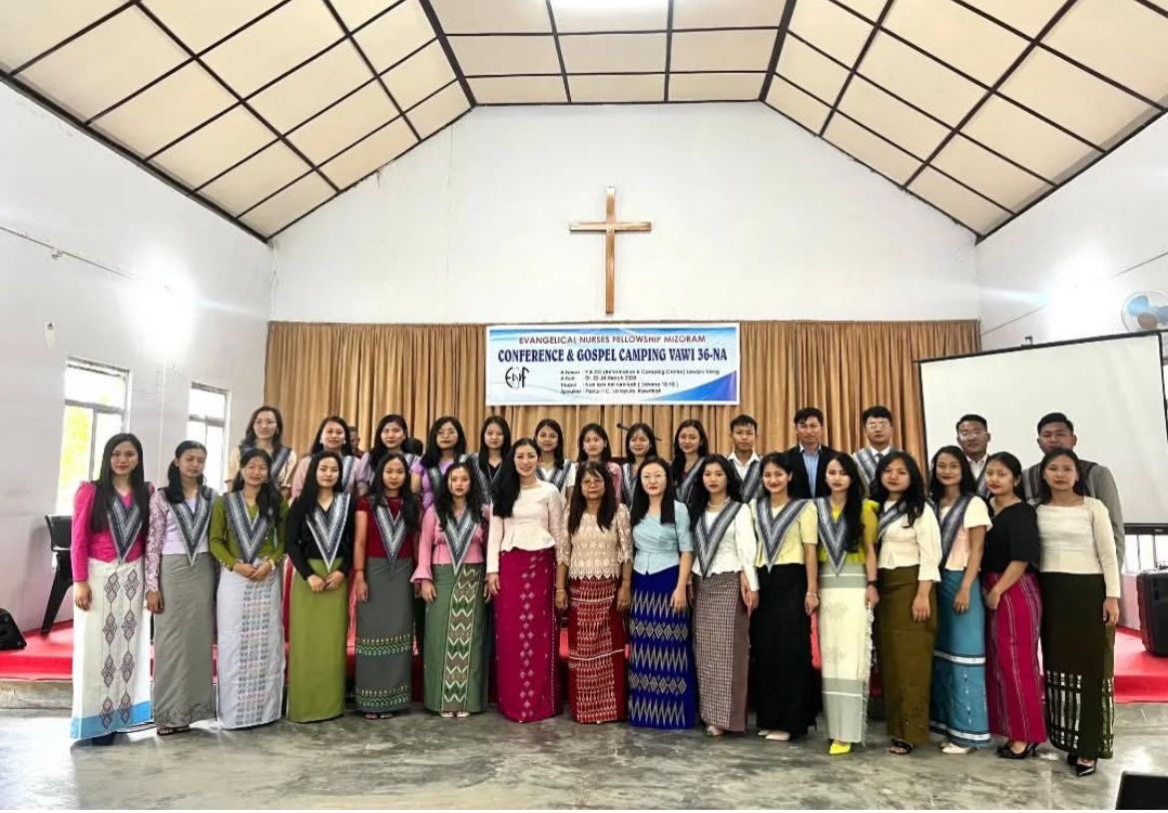
31.08.2023 : ENF BIBLE READING PROJECT-
Notebook and pen was given to two students for completing the verses given out by ENF MCON Unit during the previous session (2022-2023)

5.09.2023 : Fresher’s Induction programme
Fresher’s Induction programme organised by SNA MCON Unit was held on 5th september 2023 at Mhall at 1 pm. The session was opened with welcome speech by Miss Zulvelin. Short speech were done by the faculties and fresher. Vote of thanks was given by Samuel Lalrotlinga 4th yr.
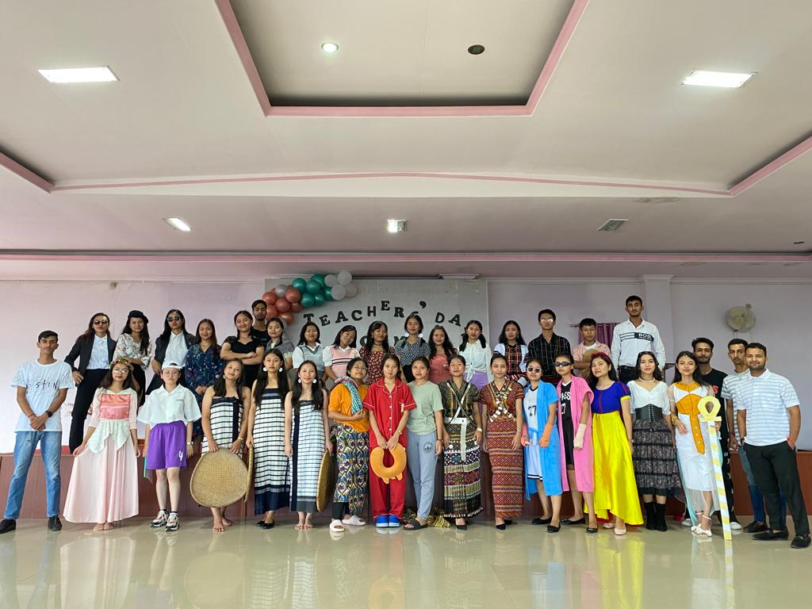
5.09.2023 : TEACHER’S DAY CELEBRATION:
- On 5th September 2023, Teachers’ day organised by SNA MCON Unit was celebrated at M hall at 1: 00 pm. The programme was opened with devotion followed by short speech, cake cutting, group singing by 5th semester, gift distribution and special items from 3rd semester.
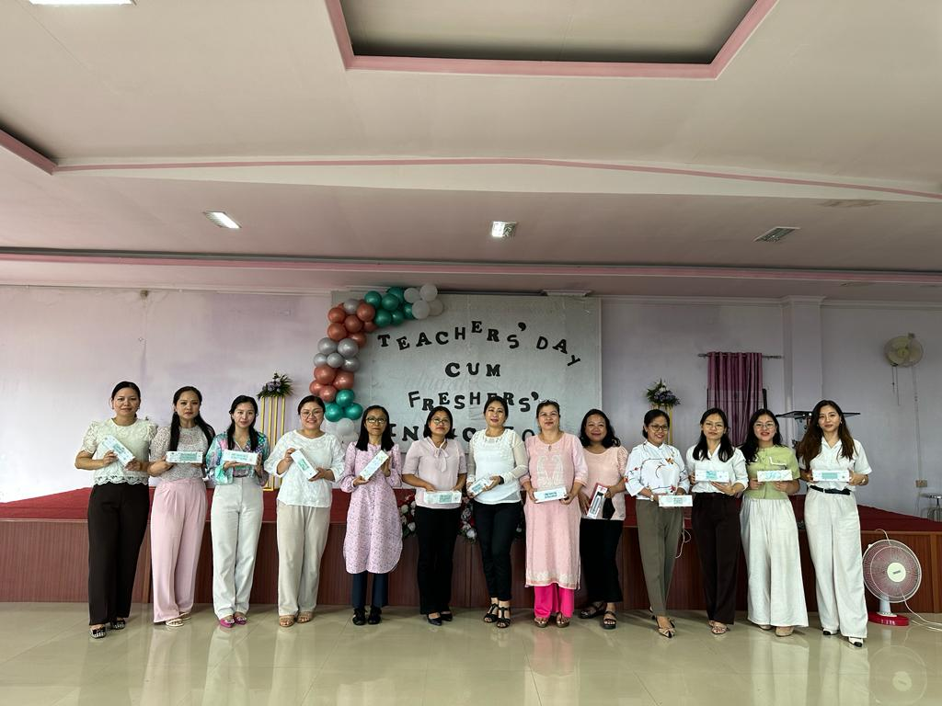
13.12.2023 : ENF RETREAT
ENF retreat programme was organized in 2 sessions at M-Hall , MCON.
Rev. Lalrinmawia gave sermon in both the sessions , who was a represent from BSI. 25 bibles (20-Mizo and 5- Hindi) were received and ENF MCON Unit has upgraded to Patron membership at BSI, an amount of Rs.5000 was given for it.
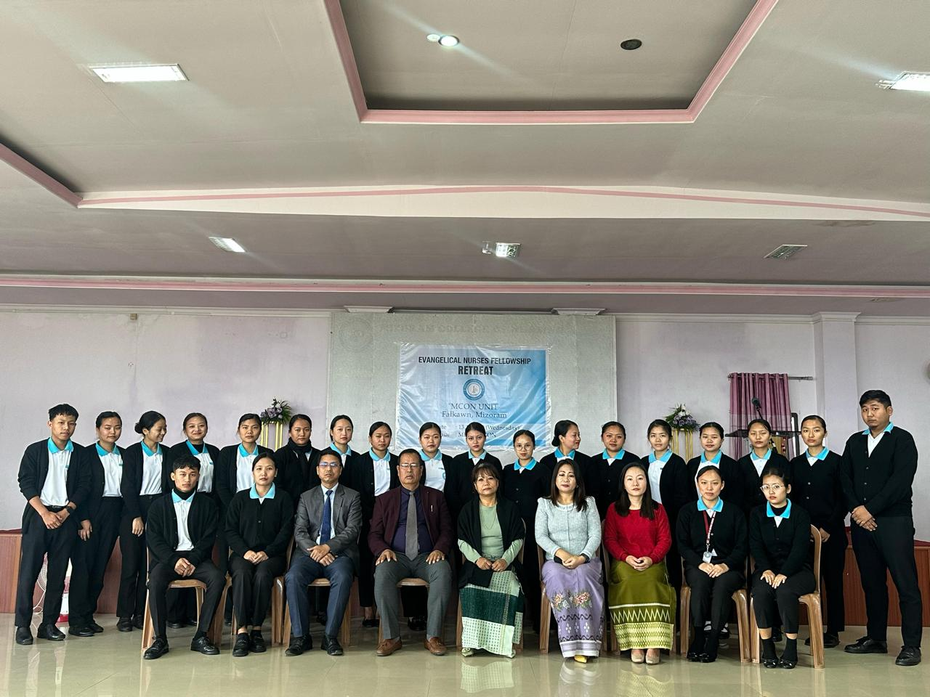
17.12.2023: CHARITY PROGRAMME-
Financial aid of Rs5000 was given to 4 families , a residents of Falkawn who faced financial hardship
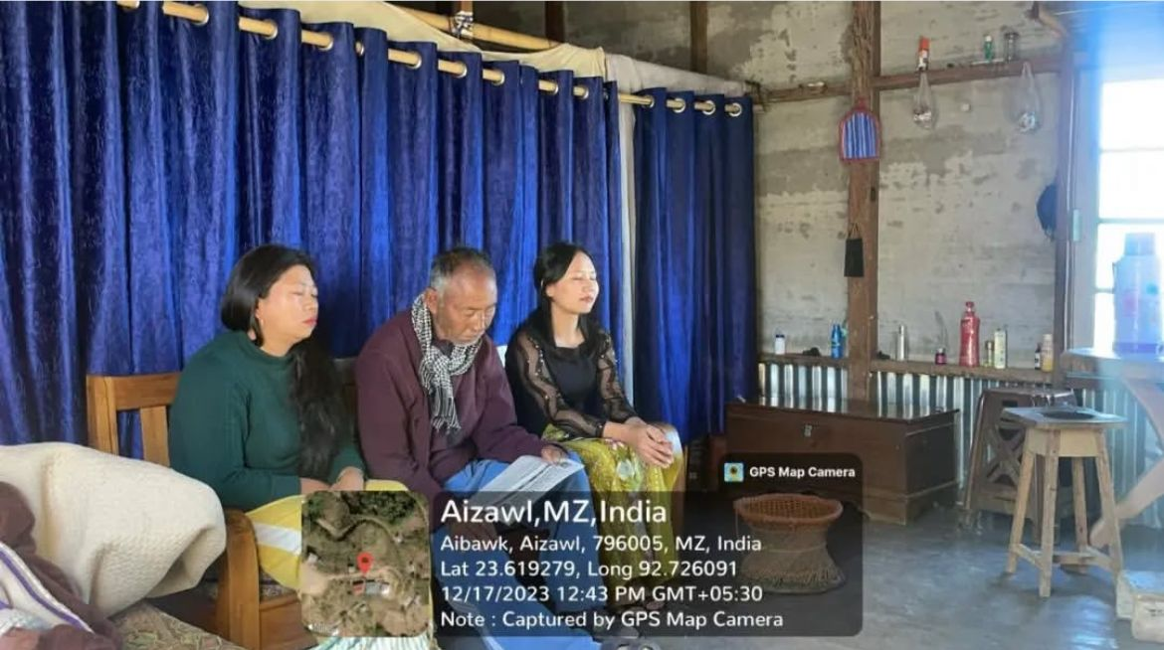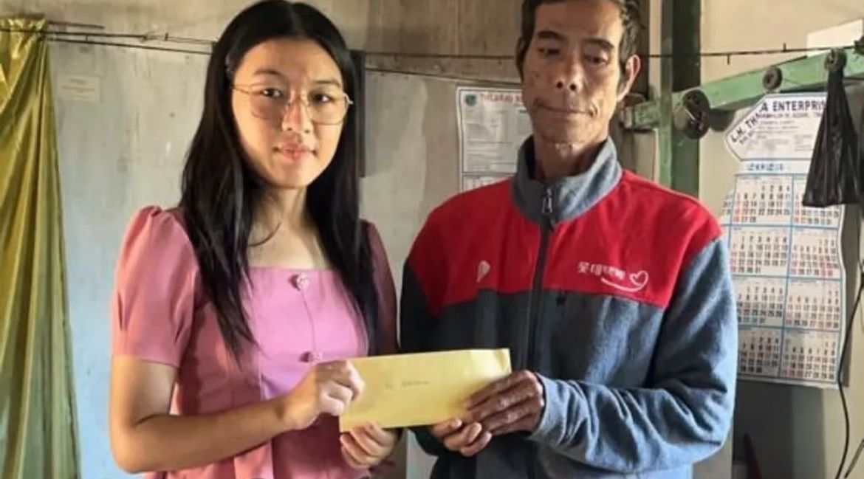
22.01.2024 , SNA UNIT ANNUAL SPORT :
22nd January 2024 (indoor night) held at students common room Block-2.
Items performed and their results are given below:
- POETRY
- 1st-Amy Lalruatkimi( green house) 2nd year
- 2nd –Vanhmingliana (blue house) 1st year
- 3rd – Rosel Lalremmawii (white house) 2nd year
- 4th –Laldingpuii Chhangte(red house) 2nd year
- PENCIL SKETCHING
- 1ST –Laltlanhlui (green house) 3rd year
- 2nd-Lalhriatrengi (blue house) 2nd year
- 3rd-Julie Lalramsangi (white house) 1st year
4th-Lalremsangi Ralte (red house) 1st year
- PAINTING
- 1ST –Lalfelkimi (blue house) 3rd year
- 2nd-VL Nunchami (green house) 2nd year
- 3rd-K.Lalbiaksangi(red house) 1ST year
- 4th-Lalhriatrengi (white house)1st year
- FLOOR DECORATION
- 1ST-Siamthantluangi (white house) 3rd year
- 2nd-Esther Lalhmingmawii Renthlei (red house) 2nd year
- 3rd-T Vanlalpekhlui (blue house) 3rd year
4th-Zorinpuii (green house)1st year

- POSTER
- 1ST-Lalchhanhimi (green house) 3rd year
- 2nd-Lalremfeli (blue house) 1st year
- 3rd-Angeline Vanlaltanpuii (red house) 1st year
- 4th-Esther Lalhmingmawii Varte (white house) 2nd year
- CARROM BOARD
- 1ST-Green house
- 2nd-White house
- 3rd-Red house
- 4th-Blue house

24 .01 .2024 : Outdoor sports held at Muallungthu field.
The items and results are given below:

- 100m race (boys)
- 1st-Michael Lalasawmliana (green house) 4th year
- 2nd-Musavir Majeed (white house) 2nd year
- 3rd-Naveed Hussain Shah (blue house) 2nd year
- 100m race (girls)
- 1st-Lalhriatrengi (white house) 1st year
- 2nd-Marina Krossnunhlimi (blue house) 4th year
3rd-Khushbu Kumari (red house) 2nd year
- SACK RACE
- 1ST-Marina Krossnunhlimi (blue house) 4th year
- 2nd-Laltlansangi (green house) 2nd year
- R.Malsawmtluangi (white house) 3rd year
- 3rd-Lalchhanhimi (green house) 3rd year
- SHOT PUT
- 1ST-K.Lalbiaksangi (red house) 1st year
- 2nd-Lalchhanhimi (green house) 3rd year
- 3rd-Lalmuankimi (blue house) 4th year
- DISCUSS THROW
- 1ST-Lalngenpuii (white house) 4th year
- 2nd-K.Lalbiaksangi (red house) 1st year
- 3RD-Malsawmkimi( blue house) 4th year
- JAVELIN THROW
- 1ST-K.Lalbiaksangi (red house) 1st year
- 2nd-Esther Lalhmingmawii Varte (white house) 2nd year
3rd-Malsawmkimi (blue house) 4th year
- 3 LEGGED RACE
- 1ST-White house
- 2nd-Green house
- 3rd-Red house
- RELAY RACE
- 1ST-White house
- 2nd-Blue hpouse
3rd-Red house
- HIGH JUMP
- 1ST-Esther Lalhmingmawii Varte (white house) 2nd year
- 2nd-Cecilia Hmangaihsangzeli (blue house) 2nd year
- 3rd-Lalchhanhimi (green house) 3rd year
- VOLLEYBALL
- 1ST-White house
- 2nd-Blue house
3rd-Red house
- TUG OF WAR
- 1ST-Blue house
- 2nd-Red house
- 3rd-Green house
- POISON BALL
- 1ST-Blue house
- 2nd-White house
3rd-Red house

25 .01. 2024 : ANNUAL SPORT CLOSING FUNCTION
The items and results are given below:
- SOLO (Mizo)
- 1st-Rosangpuii (white house) 3rd year
- 2nd-PC Lalchhuanmawii (green house) 2nd year
- 3rd-Lalfelkimi( blue house) 3rd year
- SOLO (English)
- 1st-Lalhriatrengi (white house) 1st year
- 2nd-Laltlanhlui (green house) 4th year
- 3rd-Angeline Vanlaltanpuii (red house) 1st year
- DANCE
- 1ST-Green house
- 2nd-White house
3rd- Red house
- ELOCUTION
- 1ST-C.Lalbiaksangi (blue house) 3rd year
- 2nd-Lalchhuanawmi (red house) 4th year
- 3rd-PC Lalnuntluangi (white house) 2nd year
- MISS PERSONALITY
- 1ST-Lalnunhlimi (red house) 1st year
- 2nd-Zorinpuii (green house) 1st year
- 3rd-Lalremruati ( green house) 1st year
- MISTER PERSONALITY
- 1ST-Vanhmingliana (blue house) 1st year
- 2nd-Chakshu Rajput( green house) 3rd year
3rd-Sheikh umer farookh (white house) 1st year

28-29.01.2024 : STATE SNA ANNUAL SPORTS 2024
The unit have participated in State SNA Annual sports held on 28th and 29th of February 2024.
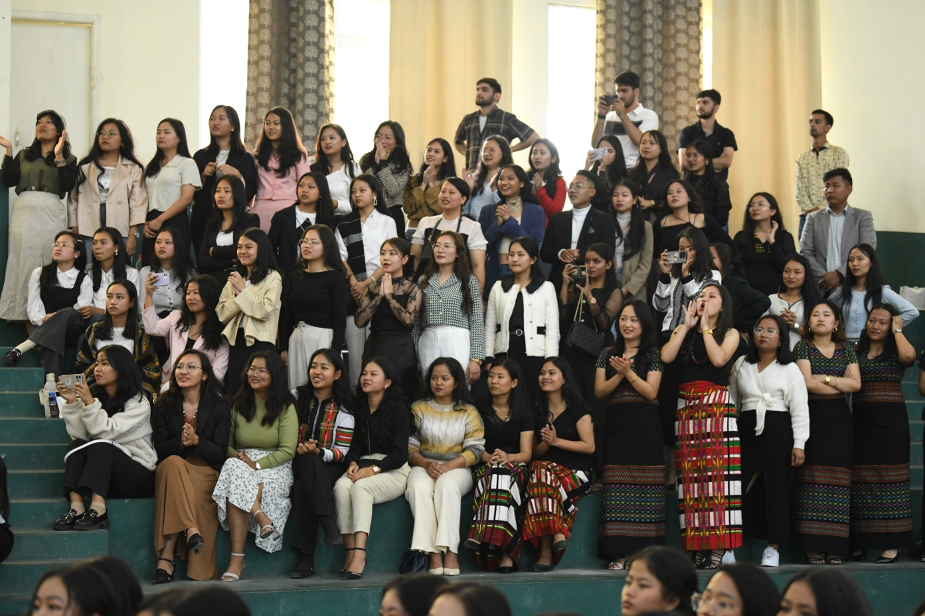
The unit have participated in all the items and the award they received are listed below:
- Javelin throw
1st -Govind Sharma 1st year
- Javelin throw (girls)
1st-K.Lalbiaksangi 1st year
- Long jump
3rd-Navid Hussain Shah 2nd year
- Poetry and recitation
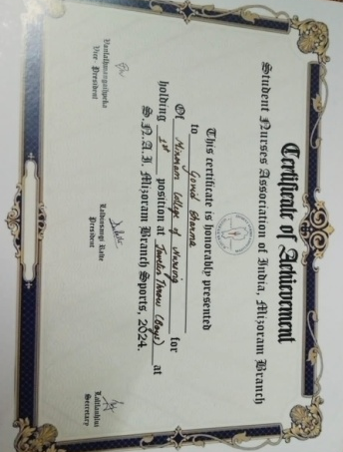
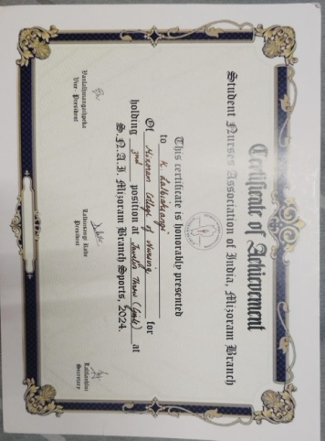
1st-Vanhmingliana 1st year

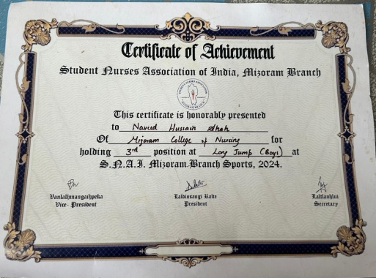
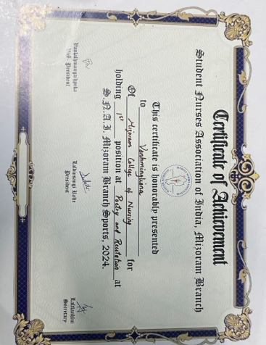
12.04.2024, 12.5.2024 : BLOOD DONATION-
- Blood donation at blood bank, Civil Hospital Aizawl, on 12. April. 2024 (On the celebration of ENF day), 15 units were donated.
- Blood donation at blood bank, State Referral Hospital, Falkawn on 12.May.2024,(On the celebration of Nurses day) 12 units were donated
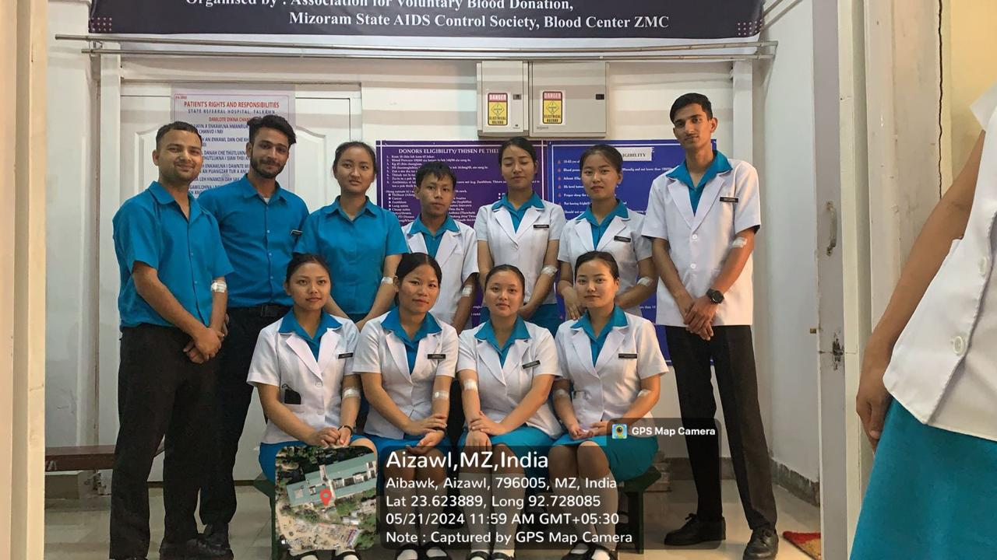
13.08.2023, 12.04.2024 : DONATIONS
- ENFI Missionary support of Rs. 1000 /- was submitted every month from July 2023- July 2024
- Donation for ENF students camping Rs. 1,6000/- was submitted to ENF Hqs.
- Donations of Rs.5000/- was submitted to poor fund at Kulikawn Hospital, Aizawl. On the observation of 49th ENF Day.
- ENF pledge is collected from all members and submitted every month to ENF Hqs.
