2.4.4.e-contents/e-courses developed
List of e-contents developed during the academic year
Sl No | Topic | File Type
1 | Soft Skills ( Elective Module) made by teachers of 1st Semester and 3rd Semester | Pdf and Hard copy
2 | Teaching materials is made by all teachers for theory classes & demonstration | Pptx, Pdf, Docx, mp4
3 | Giving a cold sponge | mp4
4 | Application of Cold Compress | mp4
5 | Application of Hot Water Bag | mp4

Link to Videos-
Mizoram College Of Nursing, Government of Mizoram, India
Teaching materials in the form of PDF, PPT, VIDEOS and DOC file used for taking classes are shared with the student from 1st year to 4th Year.
Applications/ tools used for accessing e-content/ e – courses
https://www.jhu.edu/academics/online/

Safe Delivery App - Maternity Foundation

OpenWHO: MOOCs - start to enjoy learning now

https://www.youtube.com/results?search_query=registered+nurse+rn
Link for accessing and downloading free medical textbooks in pdf form shared with the students re-
1. https://nlist.inflibnet.ac.in
2. https://www.pdfdrive.com/
3. https://www.booksasia.co.uk/
4. https://libgen.li/
5. Students are also given a joining link for Whatsapp group where free teaching materials are provided-
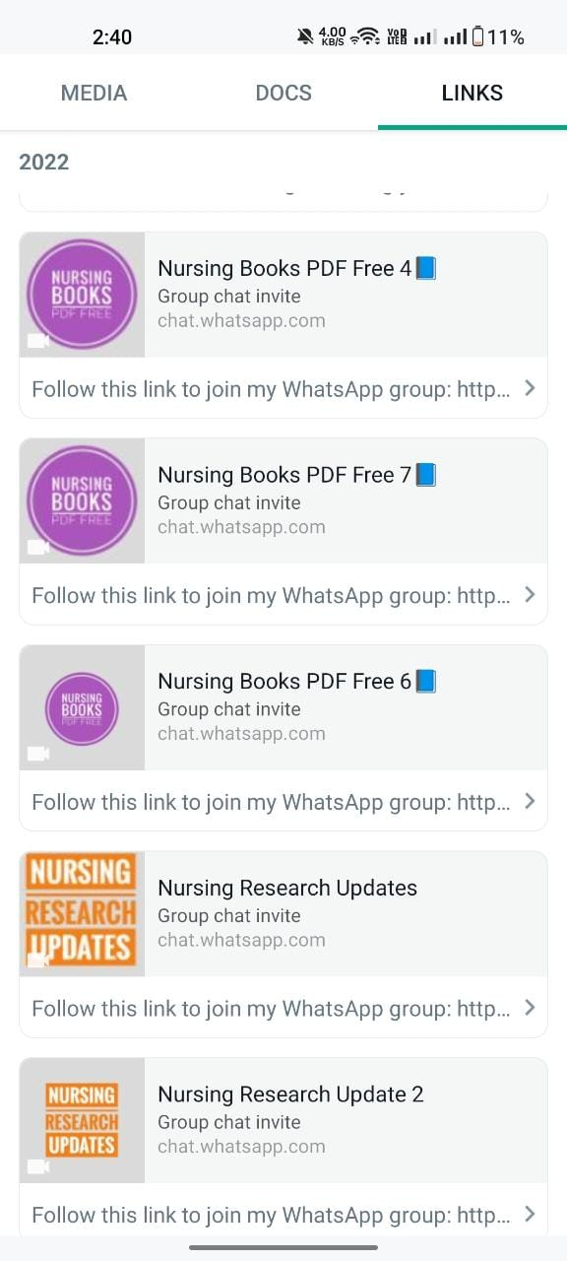
E-COURSES DEVELOPED BY MCON-ECHO

State Level e-course “e-Content Development and Delivery”

”
is developed by collaboration of MCON and ECHO India for all BSc Nursing Teaching faculty of Mizoram. It was conducted every 2 weeks on Thursday from 18 Aug 2022 to 24 Nov 2022
Description

Program Overview
To educate the teaching faculty regarding e-content development and its delivery and to aware them regarding execution of Massive Open Online Courses (MOOCs) and other Learning Management Systems. This would empower them to enhance their access to e-contents for teaching, enhance development of e-contents which may be delivered to the learners and community as a whole as e-learning has become one of the most commonly used platform for learning in today's world.

Topics Covered
- Introduction to E-Learning
- Adaptive E-Learning Content Strategies
- Content Authoring Tools
- Effective Slide Design for Online Teaching
- Advanced level slides design
- Efficient document management for e-content
- Introduction to MOOCs
- Introduction to Learning Management System
- Becoming Proficient in Open LMS for Teaching and Learning
- Techniques and tools for producing effective instructional videos
- Surveys/Polling/Quizzes

Target Audience
- Teaching faculty of higher nursing educational institutions

Certification & Credits
Certification and CNE credits given
Certificates issued under following conditions
- Attendance > 80 %
- Minimum 60% in post test after the successful completion of the program
- 40 min availability with Videos on during the session
Materials are uploaded to iecho portal, registered participants can download it.

https://iecho.org/batch/BCH16963944521417CER7M297F?tab=schedule&sessionId=SES1696394453595EXSEF8FJRX

Every week on Friday from 06 Oct 2023 to 22 Dec 2023
